PROJECT REPORT
Customer Data Analysis - Power BI

Submitted by: Jenihelan M
Project id: PTID-CDA-MAR-26-1371
Project Code: PRDA-05
Date: 23.03.2026

CHAPTER – 1: INTRODUCTION

1.1 Introduction
Customer data analysis plays a crucial role in understanding consumer purchasing behavior and improving business decision-making. By analyzing customer demographics, product categories, and payment methods, businesses can identify patterns and trends.
This project focuses on analyzing customer shopping data collected from multiple shopping malls in Istanbul between 2021 and 2023. The analysis helps understand how factors such as gender, age group, product categories, and payment methods influence purchasing behavior.
A dashboard has been created using Power BI to visually represent the data and generate meaningful insights.
1.2 Objectives of the Study
- To analyze customer shopping behavior based on gender and age group
- To identify which customer segment contributes the most to sales
- To understand product category performance
- To analyze payment method preferences
- To generate insights and provide business recommendations
1.3 Scope of the Study
- The study covers customer data from shopping malls in Istanbul
- The dataset includes transactions from 2021 to 2023
- The analysis focuses on demographic and transactional data
- The results help businesses improve marketing and sales strategies
1.4 Limitations of the Study
- The dataset is limited to selected malls in Istanbul
- No data about customer income or preferences is available
- The analysis depends on the accuracy of the given dataset
- External factors like seasonality and promotions are not considered

CHAPTER – 2: METHODOLOGY

2.1 Data Source
The dataset was provided through the internship platform and sourced from projects.datamites.com. It contains customer shopping data from 10 shopping malls between 2021 and 2023.
2.2 Dataset Description
The dataset contains detailed information about customer transactions, including demographic details and purchase behavior. The key attributes in the dataset are:
- Invoice Number: A unique identifier for each transaction
- Customer ID: Unique identifier for each customer
- Gender: Gender of the customer
- Age: Age of the customer
- Category: Product category purchased
- Quantity: Number of items purchased per transaction
- Price: Price per unit (in Turkish Lira)
- Payment method: Mode of payment (Cash, Credit Card, Debit Card)
- Invoice date: Date of transaction
- Shopping mall: Name of the shopping mall
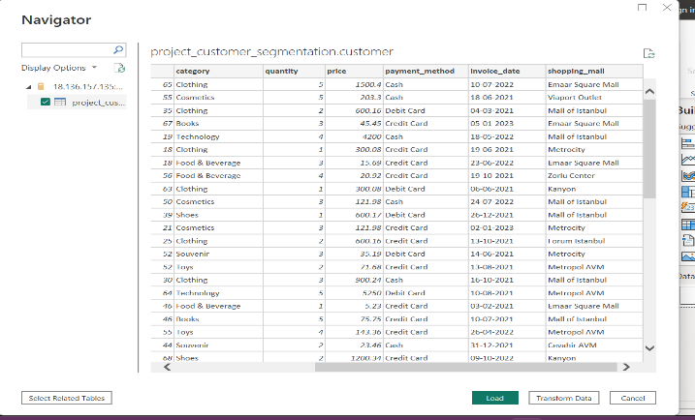
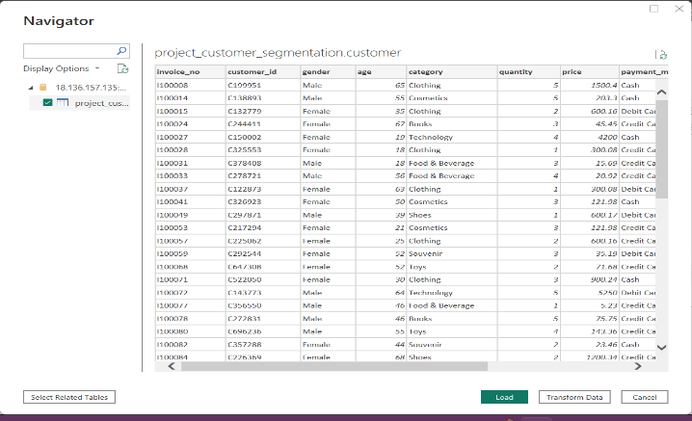

2.3 Data Preparation and Cleaning
- The dataset was connected to Power BI using the database credentials. After successfully establishing the connection, the dataset was loaded into the Power Query Editor for preprocessing and cleaning.
- The following data cleaning steps were performed:
- The dataset was reviewed to understand the structure and identify the available columns such as invoice number, customer ID, gender, age, product category, quantity, price, payment method, shopping mall, and invoice date.
- Duplicate records were checked and removed using the Remove Duplicates option based on the invoice number to ensure each transaction is unique.
3.Total Revenue Calculation:
A new measure named Total Revenue was created using the formula:
Total Revenue = Quantity × Price.
This measure helps in analyzing the total revenue generated from each purchase transaction.
- A new column named Age Group was created to categorize customers based on their age. This grouping helps in analyzing shopping behavior across different age segments.
- The age groups were defined as:
- 18–25
- 26–35
- 36–45
- 46–55
- 56+
- The column was created using the following DAX formula:
age_group =
SWITCH (
TRUE ( ),
'project_customer_segmentation customer'[Age] >= 18 && 'project_customer_segmentation customer'[Age] <= 25, "18-25",
'project_customer_segmentation customer'[Age] >= 26 && 'project_customer_segmentation customer'[Age] <= 35, "26-35",
'project_customer_segmentation customer'[Age] >= 36 && 'project_customer_segmentation customer'[Age] <= 45, "36-45",
'project_customer_segmentation customer'[Age] >= 46 && 'project_customer_segmentation customer'[Age] <= 55, "46-55",
'project_customer_segmentation customer'[Age] >= 56, "56+"
)
- These groups represent different customer segments:
18–25 → Young customers
26–35 → Early adults
36–45 → Mid-age group
46–55 → Mature customers
56+ → Senior customers
- After completing the transformations, the cleaned dataset was applied to Power BI using the Close & Apply option. The dataset is now ready for visualization and dashboard creation.
2.4 Tools and Technologies Used
- Power BI (for dashboard creation)
- Power Query (for data cleaning)
- DAX (for calculated columns)
2.5 Steps in Analysis
- Data collection
- Data cleaning and transformation
- Data modeling
- Creating visualizations
- Generating insights and recommendations

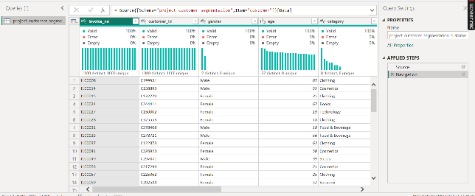

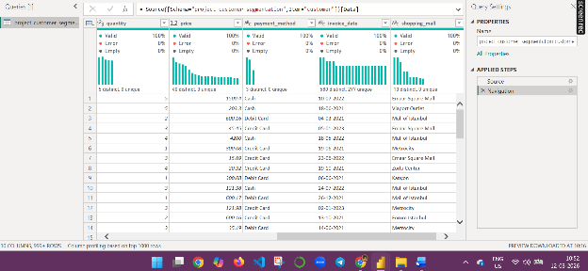

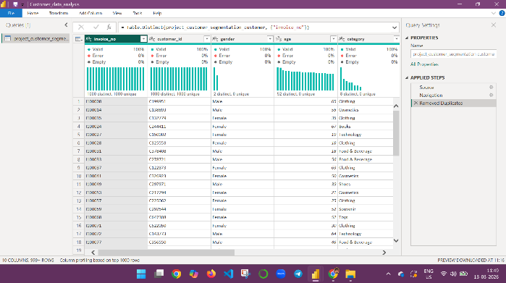
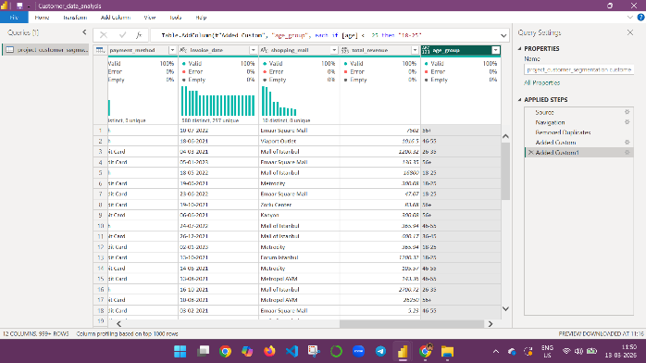

2.6 Dashboard Design
- The dashboard was designed using Power BI to provide an interactive and user-friendly analysis of customer data. The layout was structured to ensure clarity, easy navigation, and effective visualization of insights.
- The dashboard consists of four main pages:
        - Gender Based Analysis
        - Age Group Based Analysis
        - Category Based Analysis
        - Payment Based Analysis
        - Overall Insights and Recommendations.
Key features of the dashboard include:
- KPI cards displaying total sales, total transactions, and total products sold
- Interactive slicers for gender, age group, category, shopping mall, and year
- Visual charts such as bar charts, pie charts, and donut charts for analysis
- Navigation buttons like Home, Reset Filters, and Next Page for better usability
The dashboard is designed to help users explore data easily and derive meaningful insights.

CHAPTER -3: ANALYSIS

3.1 Dashboard Overview
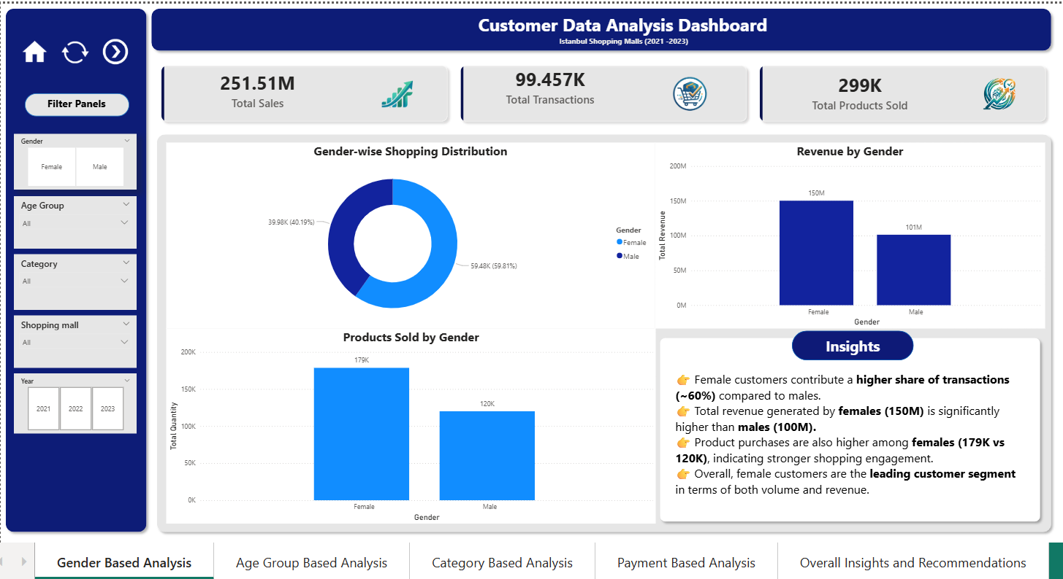
Fig 1: Gender Insights

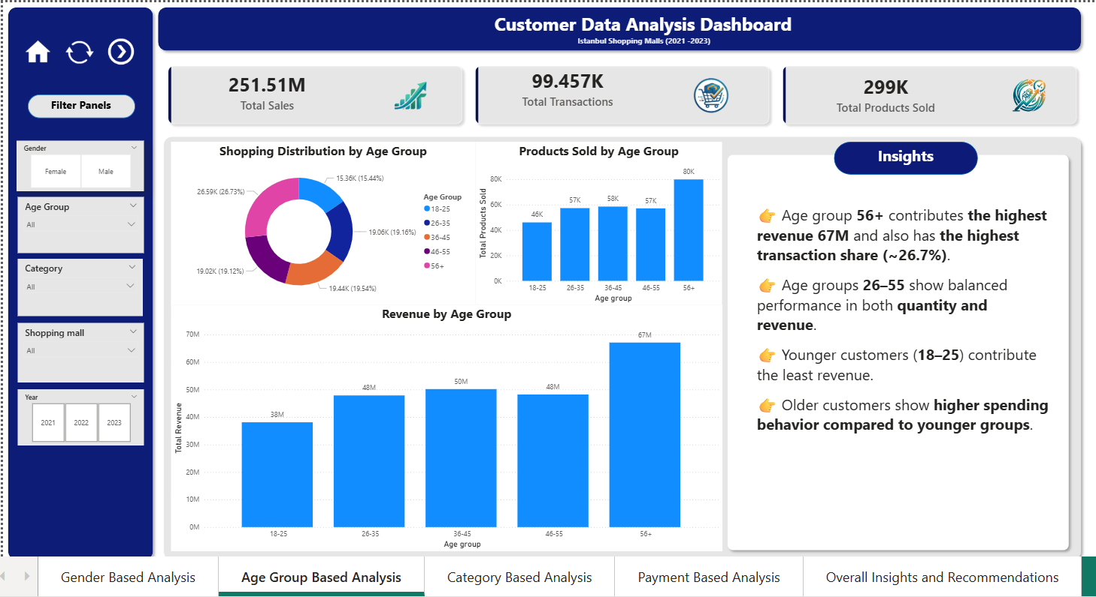
Fig 2: Age Insights

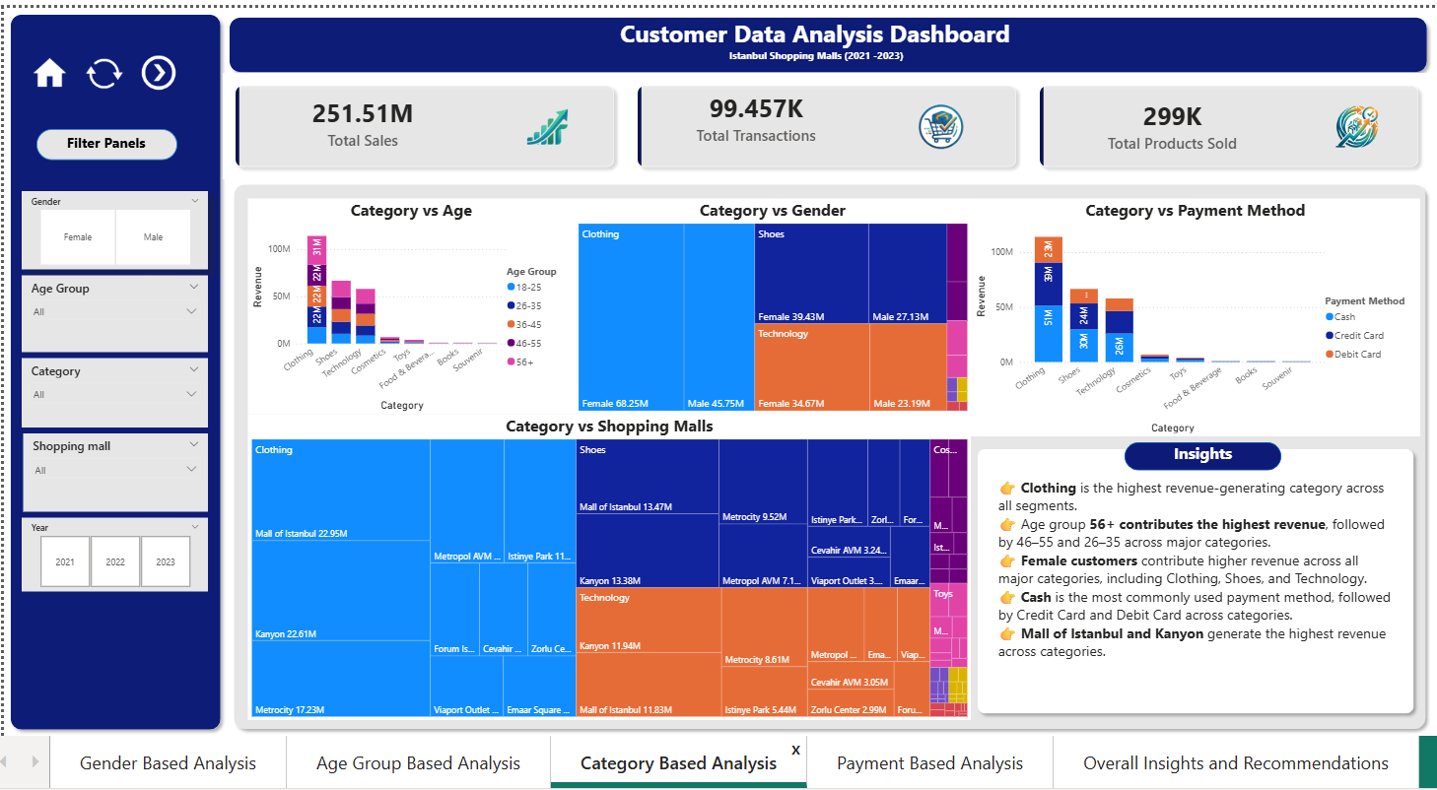
Fig 3: Category Insights

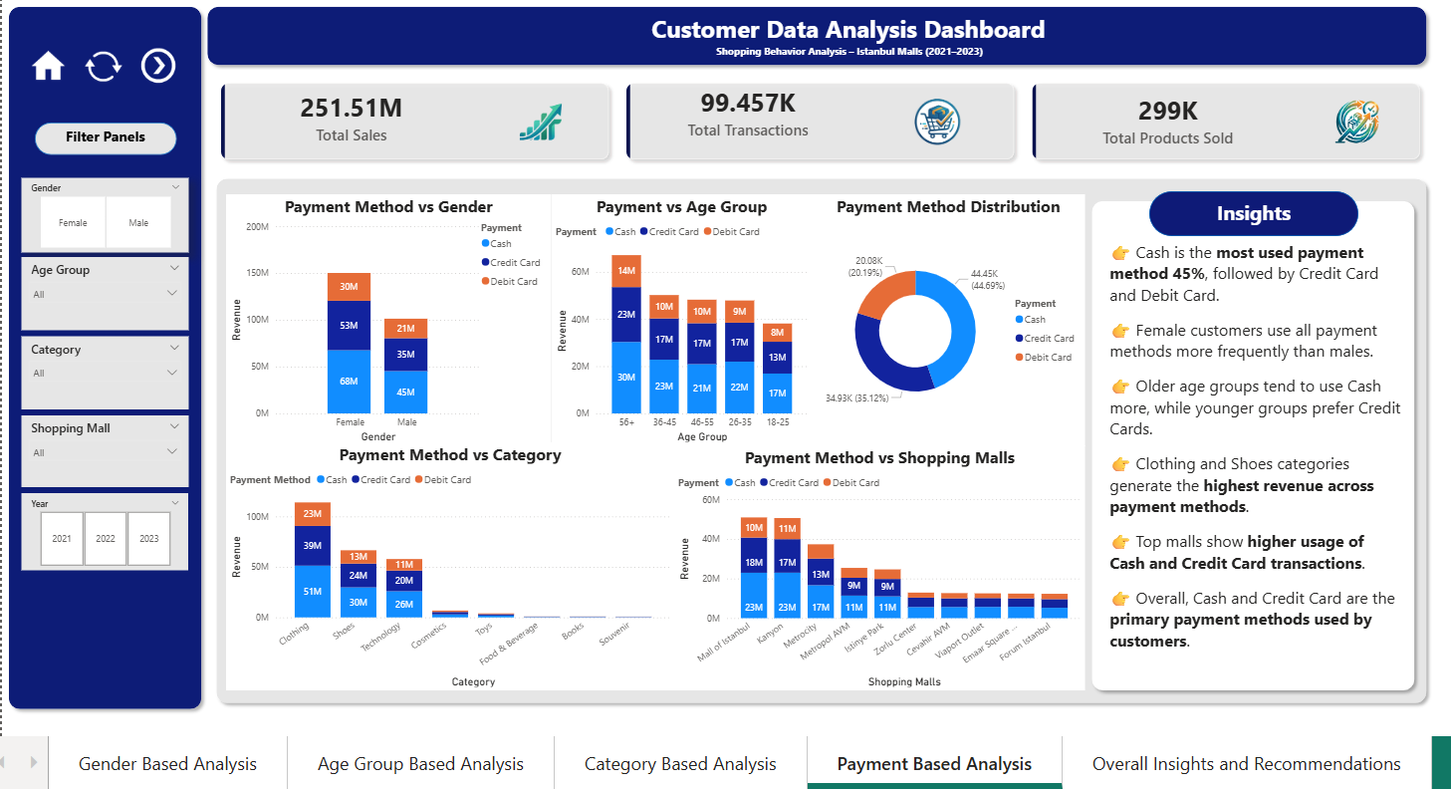
Fig 4: Payment Insights

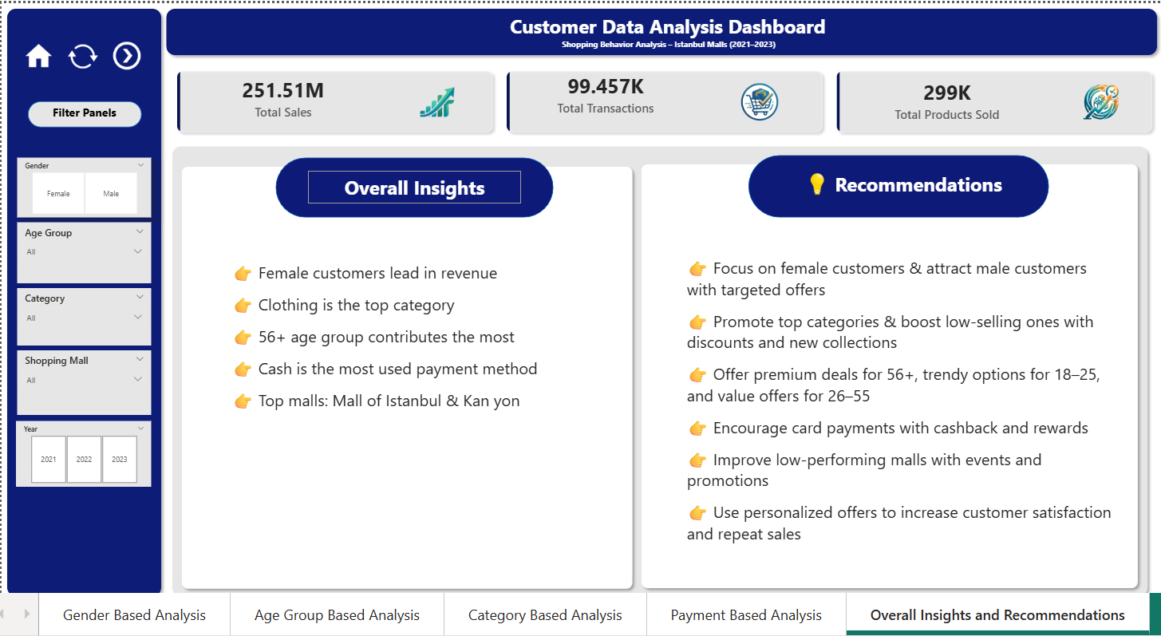
Fig 5: Overall Insights and Recommendations

Description:
This dashboard presents a comprehensive overview of customer shopping behavior across multiple shopping malls in Istanbul between 2021 and 2023. It includes key metrics such as total sales, total transactions, and total products sold, along with interactive filters and visualizations for gender, age group, and payment method analysis.
Key Metrics
The dashboard highlights important business metrics:
Total Sales: 251.51 M
Total Transactions: 99.457 K
Total Products Sold: 299 K
These KPIs provide a quick overview of the overall business performance.

Gender-Based Analysis
- The gender analysis page focuses on understanding shopping behavior differences between male and female customers.
- The analysis includes:
- Gender-wise shopping distribution
- Products sold by gender
- Revenue by gender
- The analysis of shopping behavior based on gender indicates that female customers contribute a higher proportion of total transactions compared to male customers.
- In terms of revenue, female customers generate significantly higher sales, contributing a major share of total revenue. Additionally, the total number of products purchased by female customers is also higher.
- This suggests that female customers represent a key segment in terms of both purchase volume and revenue contribution.
Age Group - Based Analysis
- Age group analysis helps identify the most active customer segments. Customers were categorized into five groups: 18–25, 26–35, 36–45, 46–55, and 56+.
- This analysis includes:
  - Shopping Distribution by Age Group
  - Products sold by age group
  - Revenue by age group
- The age-based analysis highlights that customers aged 56 and above generate the highest revenue among all age groups.
- While middle age groups (26–55) demonstrate balanced performance in terms of both quantity and revenue, younger customers (18–25) contribute relatively less to total revenue.
- This indicates that older customers have higher purchasing power and contribute more significantly to overall sales.
Category Based Analysis
- The category-wise analysis reveals that Clothing is the highest revenue-generating product category, followed by Shoes and Technology.
- Further analysis shows that customers in the age group of 26–45 contribute significantly across major categories. Gender-based comparison indicates higher contribution from female customers in key categories.
- Additionally, payment methods such as Cash and Credit Card are widely used across categories. Revenue contribution also varies across different shopping malls, indicating location-based performance differences.
Payment Method Analysis
- The payment insights page analyzes customer payment preferences.
- The analysis includes:
- Payment method vs Gender
- Payment method vs Age Group
- Payment method vs Category
- Payment method vs Shopping malls
- Payment method distribution
- The analysis of payment methods shows that Cash is the most frequently used payment method, followed by Credit Card and Debit Card.
- Payment preferences vary across different customer segments. Female customers show higher usage across all payment types. Additionally, older age groups tend to prefer Cash, while younger customers show greater usage of Credit Cards.
- Category-wise analysis indicates that high-revenue categories utilize multiple payment methods. Mall-wise analysis also shows variation in payment preferences across locations.

Overall Insights and Business Recommendations:
- This section presents the key insights derived from the overall data analysis of customer shopping behavior across different dimensions such as gender, age group, product category, and payment methods.
- Based on these insights, suitable business recommendations are provided to help improve marketing strategies, enhance customer engagement, and increase overall sales performance.

3.6 Task-Based Analysis
Task 1: How is the shopping distribution according to gender?
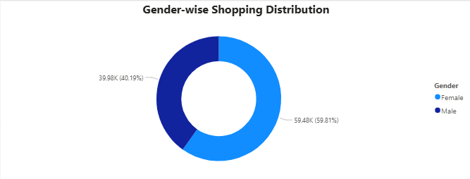
Insight:
Female customers account for the majority of transactions (~60%), while male customers contribute around 40%, indicating higher shopping participation among females.

Task 2: Which gender did we sell more products to?
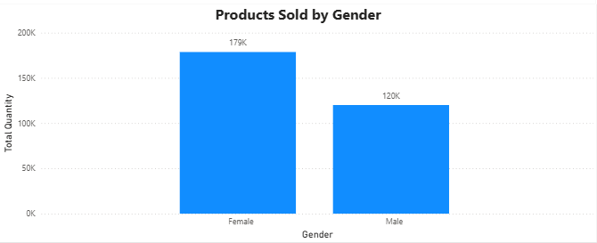
Insight:
More products were sold to female customers (~179K) compared to male customers (~120K), indicating higher purchase volume among females.

Task 3: Which gender generated more revenue?
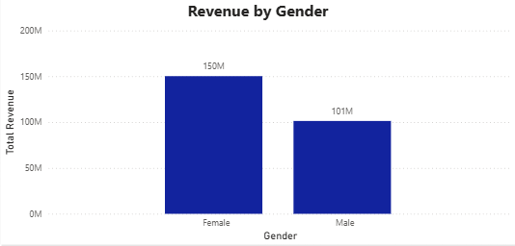
Insight:
Female customers generated higher revenue (~150M) compared to male customers (~101M), indicating that females contribute more to overall sales value.

Task 4: Distribution of purchase categories relative to other columns?
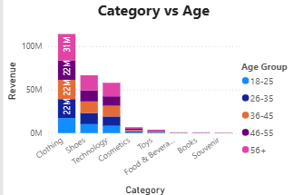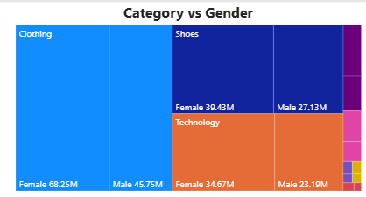
Insight:
- Clothing generates the highest revenue across all age groups, with the 56+ age group contributing the most, while age groups 26–55 show consistent performance, and the 18–25 age group contributes the least, indicating lower spending among younger customers.
- Female customers contribute higher revenue across major categories such as Clothing, Shoes, and Technology compared to male customers.

Task 5: How is the shopping distribution according to age?
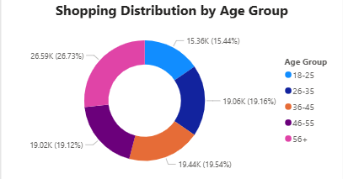
Insight:
The 56+ age group accounts for the highest share of transactions (~26.7%), while the 18–25 age group contributes the least (~15.4%), with other age groups showing relatively balanced participation.

Task 6: Which age category did we sell more products to?
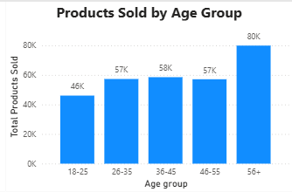
Insight:
The 56+ age group purchased the highest number of products (~80K), while the 18–25 age group purchased the least (~46K), indicating higher buying volume among older customers.

Task 7: Which age category generated more revenue?
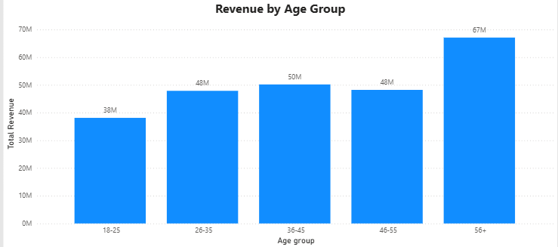
Insight:
The 56+ age group generated significant revenue of 67M, indicating strong purchasing power among older customers.

Task 8: Distribution of purchase categories relative to other columns?
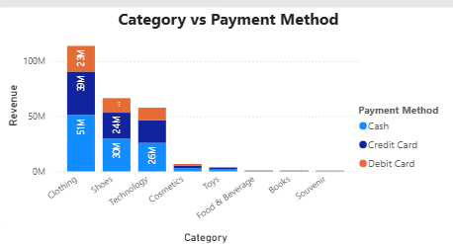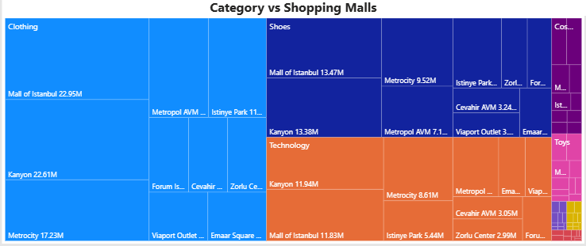
Insight:
- Cash is the most used payment method across all categories, with Clothing, Shoes, and Technology generating the highest revenue.
- Clothing dominates across all malls, with Mall of Istanbul and Kanyon contributing the highest revenue among shopping locations.

Task 9: Does the payment method have a relation with other columns?
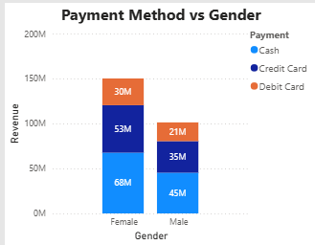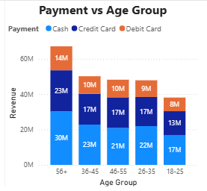

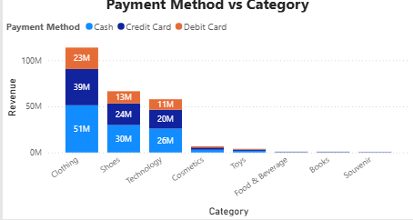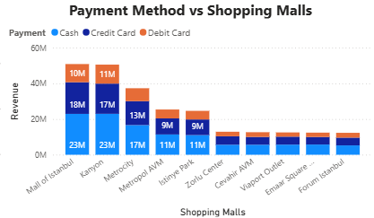
Insight:
Yes, payment method shows a strong relationship with shopping mall, product category, age group, and gender, with consistent patterns in customer preferences across all segments.

Task 10: How is the distribution of payment methods?
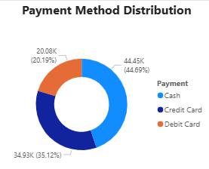
Insight:
Cash is the dominant payment method, accounting for nearly half of all transactions (44.69%), followed by Credit Cards and Debit Cards.

CHAPTER – 4: RESULTS AND CHALLENGES

4.1 Key Insights
- The overall analysis reveals that female customers contribute a higher share of transactions and generate more revenue, making them a key customer segment.
- Clothing is the highest revenue-generating category, consistently performing well across all customer groups, followed by Shoes and Technology.
- From an age perspective, customers aged 56+ contribute the highest revenue and transaction share, indicating stronger purchasing power among older customers, while younger customers (18–25) contribute the least.
- In terms of payment behavior, Cash is the most preferred payment method, followed by Credit Card, across all categories and customer segments.
- Additionally, Mall of Istanbul and Kanyon generate the highest revenue, highlighting location-based performance differences.
These insights help businesses understand customer behavior more effectively.

4.2 Business Recommendations
Based on the insights obtained from the analysis of customer shopping behavior, the following business recommendations are suggested to improve sales performance and customer engagement:
- Focus marketing campaigns on female customers to maximize revenue, while also designing targeted campaigns to increase engagement among male customers.
- Promote high-performing categories like Clothing, Shoes, and Technology, while offering discounts and bundles to boost sales in low-performing categories.
- Target older age groups (56+) with premium products, while introducing affordable and trendy products to attract younger customers (18–25).
- Encourage digital payments (Credit/Debit Cards) through cashback, discounts, and rewards to reduce dependency on cash transactions.
- Improve performance in low-performing malls through promotions, events, and localized marketing strategies.
- Implement personalized marketing based on customer age, gender, and shopping behavior to increase engagement and retention.

4.3 Challenges Faced
- Age Group Sorting Issue:
Age groups were stored as text (18–25, 26–35, etc.), which caused incorrect order in visuals.
An attempt was made to create a separate Age Group Sort column (1–5) and sort using it, but it resulted in a dependency error.
Finally, the built-in Sort by Column option in the visual was used to correctly arrange the age groups.
- Dashboard Design:
Designing a clean, organized, and well-balanced dashboard layout was challenging.
- Visualization Selection:
Choosing the most appropriate charts for each analysis required careful consideration to clearly present the insights.
4.4 Key Learnings
- This project provided valuable earning experience in data analysis and dashboard design using Power BI.
- Through this project, I learned how to:
- Prepare and validate datasets before analysis.
- Create calculated columns such as Total Revenue.
- Perform customer segmentation using age groups.
- Design interactive dashboards with KPIs and slicers.
- Select appropriate visualizations to communicate insights effectively.
- I also learned how to improve dashboard usability by adding navigation icons such as Home, Reset Filters, Next page which enhances user interaction and makes the dashboard easier to navigate.

CHAPTER – 5: CONCLUSION
5.1 Conclusion
This Customer Data Analysis of Istanbul shopping mall data (2021-2023) reveals that female customers 60% transactions, 150M (Turkish Lira) revenue and the 56+ age group 26.7% transactions, 67M (Turkish Lira) revenue drive performance, with Clothing leading categories. The interactive Power BI dashboard enables stakeholders to dynamically explore shopping patterns across demographics, product categories, and payment preferences (Cash: 44.69%). By converting raw data into actionable insights, this project demonstrates how data visualization tools like Power BI support data-driven decision-making to optimize marketing, product focus, payment adoption, and business strategies for sustained growth.

